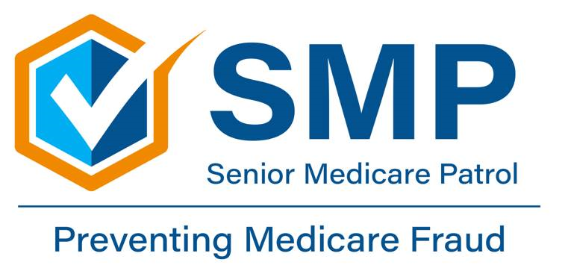
‘Care Share
April 2025
This project is supported by the Administration for Community Living (ACL), U.S. Department of Health and Human Services (HHS) as part of a financial assistance award totaling $368,803.00 with 100 percent funding by ACL/HHS. The contents are those of the author(s) and do not necessarily represent the official views of, nor an endorsement, by ACL/HHS, or the U.S. Government.
Do you know that Senior Medicare Patrols (SMP) are in every state and US protectorate? If you have friends and family in other states, you can tell them to contact SMP in their area as well. Read your Medicare statements and report any waste, fraud, or abuse to SMP. Go to smpresource.org or call 877.808.2468 from anywhere in the US.
This article is shared from a question asked to Georgia SMP: I recently attended a panel discussion at my local senior center where someone from law enforcement and a lawyer spoke to us about scams that target seniors. I understood that identity theft happens when someone takes your name and personal information like your Social Security Number or Medicare number and uses it without your permission to do things like open new credit or bank accounts, use your existing accounts, or obtain medical services. What was confusing was how this happens and what can I do to protect myself?
There are several ways that scammers can steal your identity, including in person, online, through social media, and by phone. When thieves pick your pockets, steal your wallet or purse, or steal your mail from the mailbox, they can have access to your driver’s license (principal form of ID), credit or debit cards, social security card and/or Medicare card. They may go through your trash to get your personal information such as bank statements, tax documents, and medical insurance claim/payment notices. Using a shredder is always helpful when discarding your important paperwork.
Identity theft often occurs when a scammer pretends to be someone you trust — a government agency like the Social Security Administration or the IRS, Medicare, a family member (typically a grandchild), a love interest, or someone claiming there’s a problem with your computer. The scammer can even have a fake name or number show up on your caller ID to convince you. Scammers often use phone solicitation to obtain personal information that allows them access to your identity. This is particularly true of Medicare phone scams. The caller can use your stolen information to open credit cards, bank accounts, order medical supplies you don’t need— leaving you to pick up the pieces and dispute the debts.
Medical Identity theft can occur when someone steals your personal healthcare information (Medicare or Medicaid number, Social Security number, prescription drug card or other medical identification card) to access your benefits. Thieves can use your personal information to bill your insurance for medical supplies or services that you did not order or receive. With medical identity theft, some beneficiaries unknowingly or accidentally give their Medicare and social security numbers out to scammers claiming to be from Medicare or other government agencies.
Once the scammer has a beneficiary’s Medicare number it is considered “compromised” and steps should be taken to protect the beneficiary, including contacting your local SMP and Medicare to report the incident. You may have been the victim of medical identity theft if you notice a claim on your Medicare Summary Notice (MSN) or Explanation of Benefits (EOB) for services or medical equipment that you did not receive. You may receive a notice from a collection agency about a medical bill that you don’t recognize, or you notice medical debt collections on your credit bureau report.
Examples of medical identity theft include when someone calls you on the phone claiming to be from Medicare. The caller asks for your Medicare number so they can send you a “new” plastic Medicare card or one that has a chip in it. (Note: Medicare is not mailing new cards; this is a scam!)
Another scam is someone calls you on the phone or sends you something in the mail offering free or low-cost medical equipment in exchange for your Medicare number. If you give them your information, they can bill Medicare for braces or other medical equipment. Other scams may involve genetic testing, whole body scans and lab testing.
To protect yourself from becoming a victim of medical identity theft, you should avoid giving out your Medicare number to strangers over the phone or via the internet. Review your Medicare Summary Notices (MSN) and Explanation of Benefits (EOB) for accuracy and shred all personal and medical related documents before you throw them away. Use caution when purchasing medical supplies or equipment from online advertisements and phone solicitations. Using local vendors is helpful.
The Federal Trade Commission Consumer Advice online portal has excellent information on how to protect your personal information from hackers and scammers. If you discover an issue, it’s important to act quickly. If you think someone is using your personal information, go to IdentityTheft.gov to report it and get a personalized recovery plan.
And finally, if you suspect that you are at risk or may be a victim of Medicare fraud, report it to Senior Medicare Patrol (SMP) immediately. In Montana call 800-551-3191, for assistance with Medicare scams, waste, or abuse. Reporting any possible errors or fraud helps to save your benefits and protects others from becoming a victim!
Lynn Rosenblatt, RN (retired) & SMP Volunteer

Ask SMP: How Does Identity Theft Happen and How Can I Protect Myself?
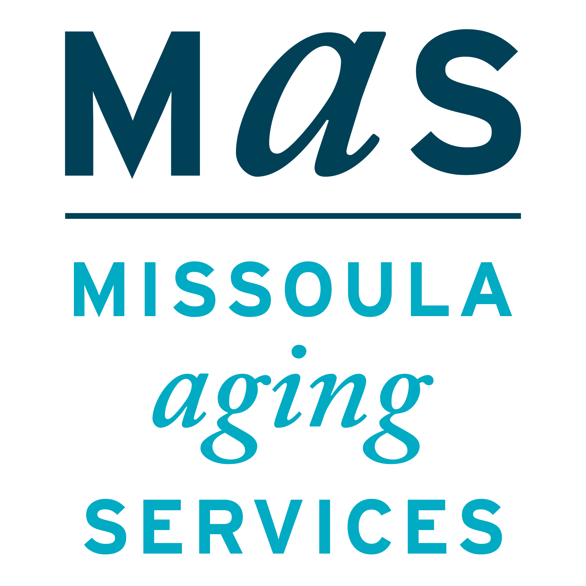
Montana SMP is a program coordinated by Missoula Aging Services and partnered with local Area Agencies on Aging. This project was supported by grant #90MPPG0052 from the U.S. Administration for Community Living, Department of Health and Human Services, Washington D.C., 20201. Points of view or opinions do not necessarily represent official ACL policy.

The Senior Medicare Patrol (SMP) is ready to provide you with the information you need to PROTECT yourself from Medicare fraud, errors, and abuse; DETECT potential fraud, errors, and abuse; and REPORT your concerns. SMPs help educate and empower Medicare beneficiaries in the fight against health care fraud. Your SMP can help you with your questions, concerns, or complaints about potential fraud and abuse issues. It also provides information and educational presentations. To reach Montana Senior Medicare Patrol, call 1-800-551-3191 or visit www.smpresource.org.

