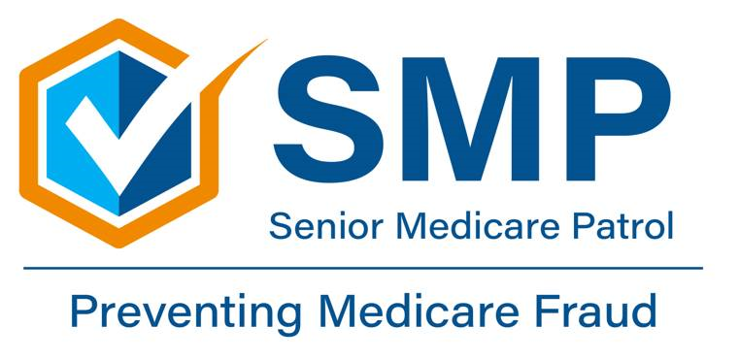
‘Care Share
May 2025
This project is supported by the Administration for Community Living (ACL), U.S. Department of Health and Human Services (HHS) as part of a financial assistance award totaling $368,803.00 with 100 percent funding by ACL/HHS. The contents are those of the author(s) and do not necessarily represent the official views of, nor an endorsement, by ACL/HHS, or the U.S. Government.
Durable Medical Equipment (DME) fraud is a growing issue impacting Medicare and its beneficiaries. DME includes items like wheelchairs, walkers, oxygen equipment and hospital beds—essential tools for many seniors and individuals with disabilities. Unfortunately, some suppliers and scammers exploit the system for personal gain.
What Is DME Fraud?
DME fraud is when suppliers bill Medicare for:
- Equipment not provided
- Equipment not medically necessary
- More expensive versions of a product than what was delivered
- Duplicate claims for the same item
- Using stolen or fake Medicare numbers
This form of fraud drains billions from Medicare resulting in increased costs and limited access to needed care for legitimate patients.
Common Red Flags
Be alert to these warning signs:
- You’re billed for equipment you never received
- You receive medical supplies you didn’t order
- A "free" medical equipment offer that asks for your Medicare number
- Pressure from telemarketers or door-to-door salespeople

How You Can Protect Yourself
- Check Your Medicare Summary Notice (MSN) or Explanation of Benefits (EOB) regularly for unfamiliar charges.
- Guard your Medicare number like a credit card—don’t give it out to strangers.
- Be skeptical of unsolicited offers, especially those too good to be true.
- Report suspicious activity to 1-800-MEDICARE, the HHS Office of Inspector General at 1-800-HHS-TIPS or contact your local SMP.
Medicare Is Taking Action
The Centers for Medicare & Medicaid Services (CMS) is ramping up fraud prevention by:
- Increasing supplier screening
- Using advanced data analytics to detect abnormal billing patterns
- Working closely with law enforcement to prosecute fraudsters
Stay Informed. Stay Protected.
For more resources and fraud alerts, visit www.Medicare.gov/fraud.
Have questions or need help reviewing your Medicare statements? Reach out to your local Senior Medicare Patrol (SMP) or State Health Insurance Assistance Program (SHIP) at 1-800-551-3191 to reach someone to assist you at your local Area Agency on Aging.
DME Fraud – What You Need to Know
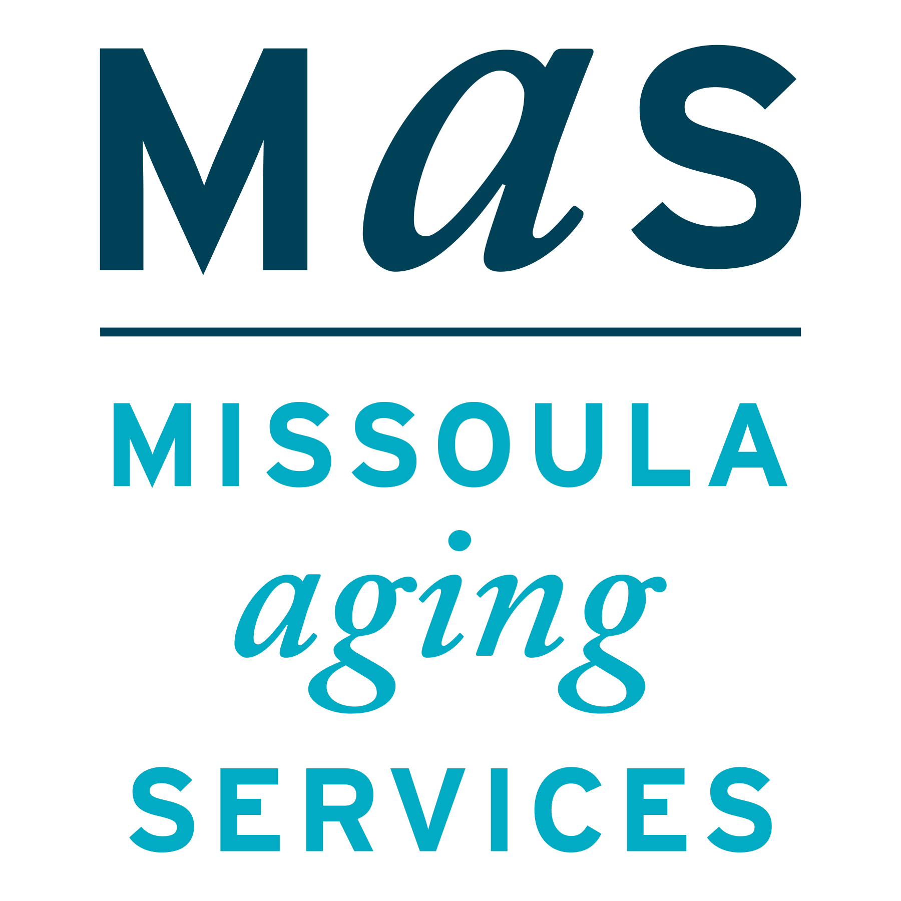
Montana SMP is a program coordinated by Missoula Aging Services and partnered with local Area Agencies on Aging. This project was supported by grant #90MPPG0052 from the U.S. Administration for Community Living, Department of Health and Human Services, Washington D.C., 20201. Points of view or opinions do not necessarily represent official ACL policy.

