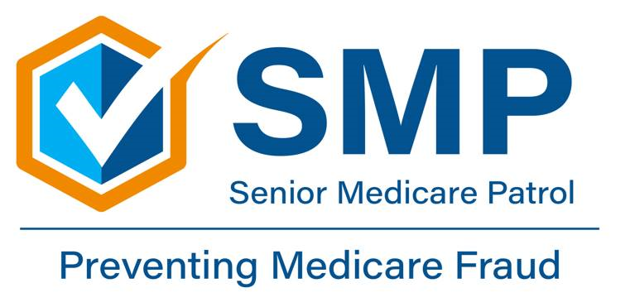
‘Care Share
July 2025
Pharmacy/Prescription Drug Fraud and Medical Identity Theft
July 08, 2025
Corinth, Mississippi
Ricky “Rick” Wayne Quinn and John Anthony “Andy” Null were indicted by a federal grand jury for conspiracy to commit health care fraud. According to the indictment, the men hatched a scheme to submit bills to Medicare and Medicaid for expensive drugs that were prescribed, then repurchased unopened from the patients for cash at a much lower price. The drugs were then placed in inventory. (Note: Ricky Wayne Quinn is the owner of Medical Plaza at Alcorn, LLC, doing business as Medical Plaza Pharmacy.) --------------------------------------------------------------------------Pharmacy and prescription drug fraud is a consistent trend in Medicare. Due to the lucrative nature of prescription drug diversion and pharmacy scams, criminals continue to exploit Medicare Part D.
What is Medicare Pharmacy/Prescription Drug Fraud?

Although there are many types of prescription drug schemes, pharmacy fraud primarily occurs when Medicare is billed for a medication that was not received or a beneficiary is intentionally given a different prescription drug than prescribed.
What are Examples of Pharmacy/Prescription Drug Fraud?

1) Billing Medicare for prescription drugs (including refills) that were never picked up, delivered, or even prescribed.

2) Billing Medicare for prescription drugs (occasionally controlled substances such as opioids) that were prescribed by a health care provider you have never seen.

3) Billing Medicare for medication amounts beyond the quantity you were prescribed.

4) Billing Medicare for a different prescription drug (often more expensive) than the one you were originally prescribed or issuing you a drug that is not approved by the U.S. Food and Drug Administration (FDA).

5) A company offering you “free” or “discount” prescription drugs without a treating physician’s order and then billing Medicare.

6) An individual offering to pay you for the use of your Medicare number to bill for prescription drugs or offering you cash or

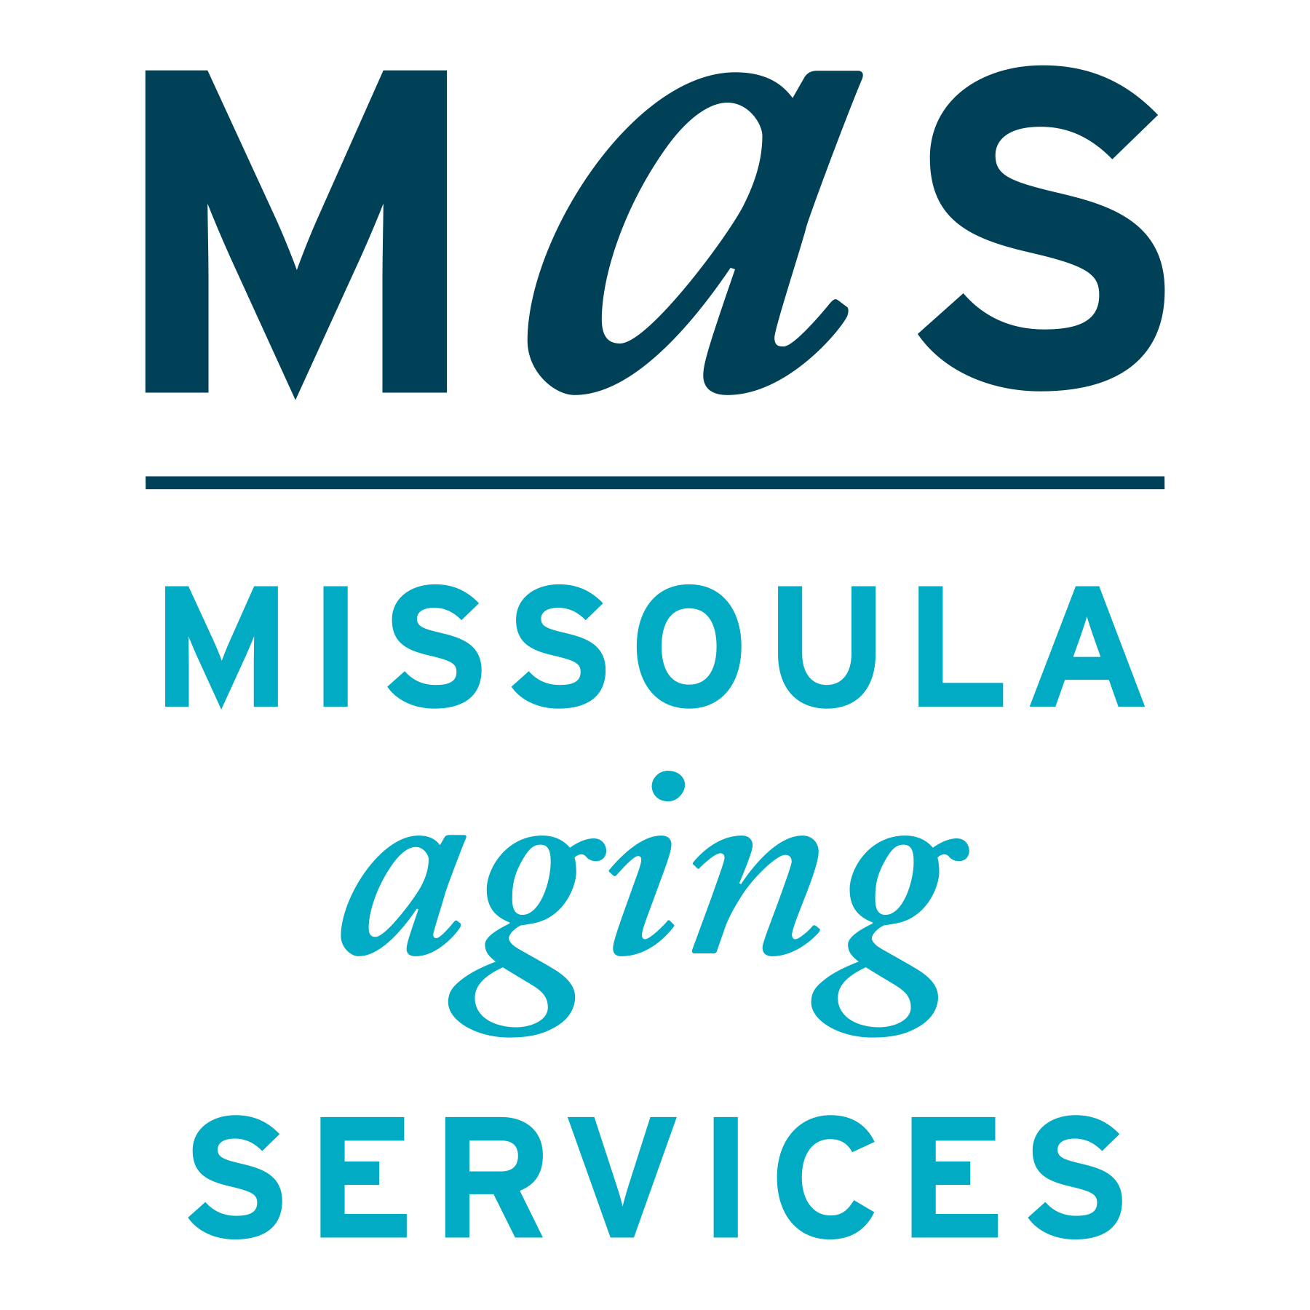
Pharmacy/Prescription Drug Fraud Tips to Protect Yourself and Medicare

Montana SMP is a program coordinated by Missoula Aging Services and partnered with local Area Agencies on Aging. This project was supported by grant #90MPPG0052 from the U.S. Administration for Community Living, Department of Health and Human Services, Washington D.C., 20201. Points of view or opinions do not necessarily represent official ACL policy.
7) A pharmacy that intentionally provides less medication than prescribed; issues expired drugs; provides and bills for an expensive compounded medication (including topical pain creams) when a traditional or less expensive prescription was ordered by your provider; offering gift cards or other compensation so you switch your prescriptions over to a specific pharmacy; automatically refilling a prescription you no longer need and don’t pick up, but still bills Medicare.

What Can You Do to Stop Pharmacy/Prescription Drug Fraud?

1) Be sure your doctor has assessed your condition before prescribing you any medication.

2) Do not give out your Medicare number or other personal information to unknown individuals requesting it for prescription drug services. Be suspicious of all unsolicited calls and offers for “free” or “discount” prescription drugs.

3) Always read your Medicare Summary Notice (MSN) or Explanation of Benefits (EOB) to watch for the names of unknown providers and billing of prescriptions and other services you did not receive.

4) If you notice a charge to your Medicare drug plan for prescriptions you did not receive (or for different drugs than the ones you were prescribed), report your concerns about possible fraud, errors, or abuse to your local SMP.

Be especially wary if someone requests your Medicare number (and/or possibly driver’s license) to evaluate your prescription history at a health fair, senior center, assisted living facility, mall, farmers market, home show, parking lot outside retail stores, or a privately sponsored wellness event. These venues are high risk for medical identity theft. Medical identity theft occurs when someone steals or uses your Medicare number to submit fraudulent claims to Medicare without your authorization. Medical identity theft may disrupt your medical care and/or result in financial harm.

How are Fraudsters Benefiting from Pharmacy/Prescription Drug Fraud?

Criminals, ranging from health care providers to drug trafficking organizations, continue to commit prescription drug fraud because it is profitable. Unfortunately, there is a strong illegal market for prescription drugs – including controlled drugs such as opioids and expensive prescriptions such as autoimmune medications like Xeljanz. Some prescription drugs are targeted because they can be combined with recreational and illegal drugs to enhance a high or hallucinogenic effect.
_____________________________________________
Source: Senior Medicare Patrol website: https://smpresource.org/
Lead Story: Corinth pharmacists accused of defrauding Medicare and Medicaid | Crime & Law Enforcement | djournal.com
The Senior Medicare Patrol (SMP) is ready to provide you with the information you need to PROTECT yourself from Medicare fraud, errors, and abuse; DETECT potential fraud, errors, and abuse; and REPORT your concerns. SMPs help educate and empower Medicare beneficiaries in the fight against health care fraud. Your SMP can help you with your questions, concerns, or complaints about potential fraud and abuse issues. It also provides information and educational presentations. To reach Montana Senior Medicare Patrol, call 1-800-551-3191 or visit www.smpresource.org.

The Senior Medicare Patrol (SMP) is ready to provide you with the information you need to PROTECT yourself from Medicare fraud, errors, and abuse; DETECT potential fraud, errors, and abuse; and REPORT your concerns. SMPs help educate and empower Medicare beneficiaries in the fight against health care fraud. Your SMP can help you with your questions, concerns, or complaints about potential fraud and abuse issues. It also
des information and educational presentations. To reach Montana Senior Medicare Patrol, call 1-800-551-3191 or visit www.smpresource.org.

