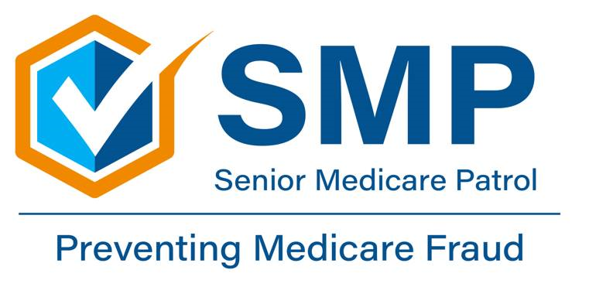
‘Care Share
March 2026

Hello, Medicare Beneficiaries!
In this month’s ‘Care Share, we’re looking at how to spot a Medicare scam.

Every year, scammers steal billions of dollars meant for the health of our communities. We know that the best way to keep your family safe is by knowing exactly what you're up against. Let’s walk through how these scams work so you can spot a tall tale before it costs you.

How the Scam Works

1. The Bait
It usually starts with a surprise: a phone call, a text, or even a knock at the door. They’ll claim they’re from Medicare or a doctor's office. They might promise you a "free" back brace, a DNA test, or a fancy new plastic Medicare card. What is Medical Identity Theft?

- The Truth: Medicare isn’t going to call you out of the blue to ask for your personal info.

2. The Fast Talk

Once they’ve got you talking, they’ll ask for your Medicare number. They might act like it’s an emergency or tell you that your benefits will be cut off if you don’t hurry.

- The Truth: If someone is rushing you or making an offer that sounds too good to be true, it’s a scam. Plain and simple.

3. The Paperwork Shuffle

If they get your number, they start billing Medicare for equipment or services you never asked for and never received. You might not even know it’s happening unless you’re looking closely at your statements.

4. The Sting

This is where it hurts. If a scammer uses up your benefits on fake claims, Medicare might say "no" when you need a real procedure later. It can also lead to identity theft, which is a headache nobody needs.

How to Protect Yourself

Keeping your benefits safe is just like keeping your livestock or your land secure. It takes a little bit of grit.

- Guard your numbers: Never give out your Medicare or Social Security number to anyone who contacts you unexpectedly.

- Nothing is "free": If they need your Medicare number to give you a "free" gift, it isn't free.

- Check your mail: Take a look at your Medicare Summary Notice when it arrives. If you see a charge for a doctor, you didn't visit or a brace you didn't get, call SMP.

How can your local SMP help?

Your local SMP can help educate and empower Medicare beneficiaries in the fight against health care fraud. Your SMP can help you with your questions, concerns, or complaints about potential fraud and abuse issues. It also can provide information and educational presentations. Always feel free to reach out!
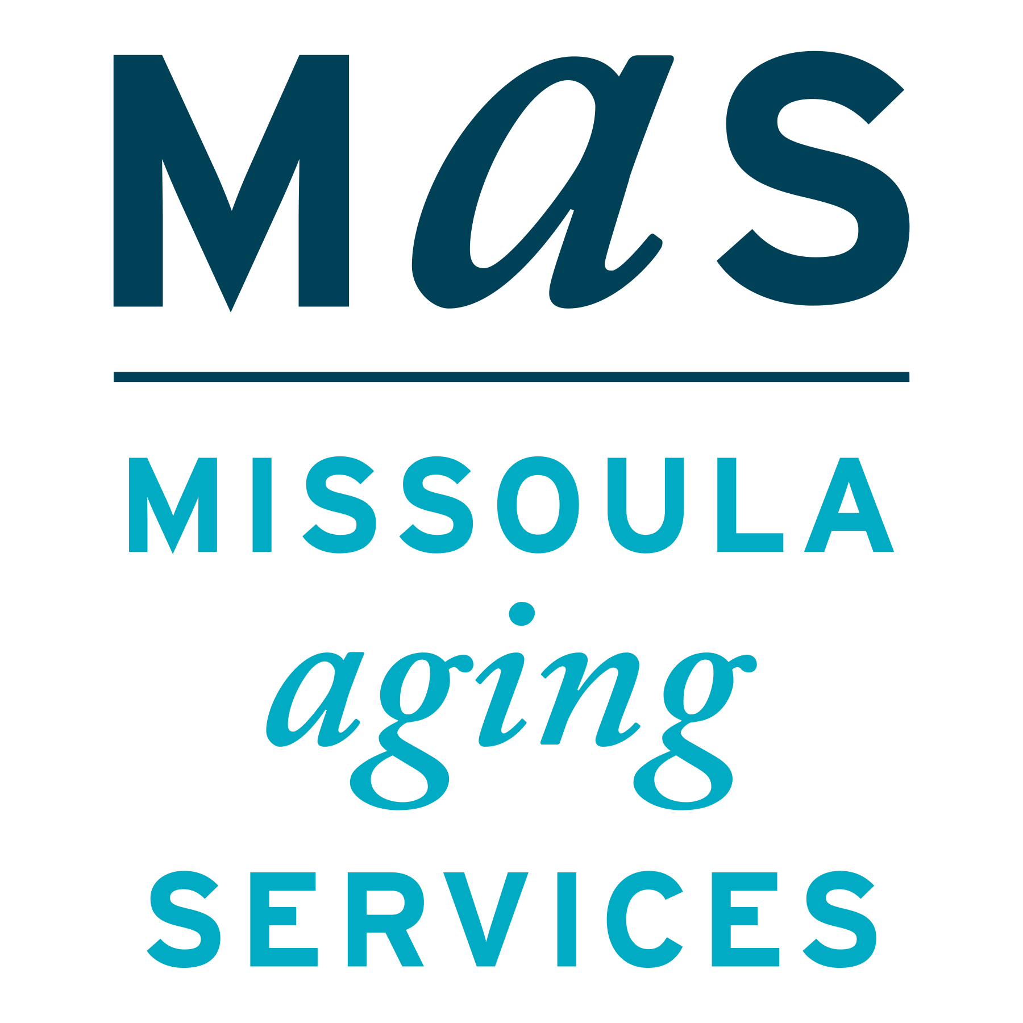
Montana SMP is a program coordinated by Missoula Aging Services and partnered with local Area Agencies on Aging. This project was supported by grant #90MPPG0095 from the U.S. Administration for Community Living, Department of Health and Human Services, Washington D.C., 20201. Points of view or opinions do not necessarily represent official ACL policy.
Medicare Scams
The Senior Medicare Patrol (SMP) is ready to provide you with the information you need to PROTECT yourself from Medicare fraud, errors, and abuse; DETECT potential fraud, errors, and abuse; and REPORT your concerns. SMPs help educate and empower Medicare beneficiaries in the fight against health care fraud. Your SMP can help you with your questions, concerns, or complaints about potential fraud and abuse issues. It also provides information and educational presentations. To reach Montana Senior Medicare Patrol, call 1-800-551-3191 or visit www.smpresource.org.

