Back Roads of Montana Memories and Stories
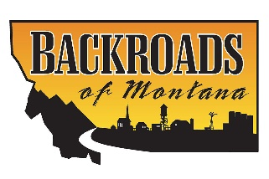
Dates: Sept. 26th, Oct. 24th & Nov. 21st, 2022, Monday’s
Time: 12:30 – 1:30 pm
Location: Card Room, Rocky Senior Center
No Cost!
The event called Rocky Backroads of Montana, Memories and Stories is coming back! The first 2 gatherings earlier this year were fun and the folks had a good time watching an episode of Backroads of Montana and then sharing their stories and memories of their Montana roots. This is a free gathering that will take place on Monday’s starting about 12:30 after lunch. Everyone is invited and there is no cost. There will be some refreshments as we relax and enjoy. Mark your calendars and come join us!

