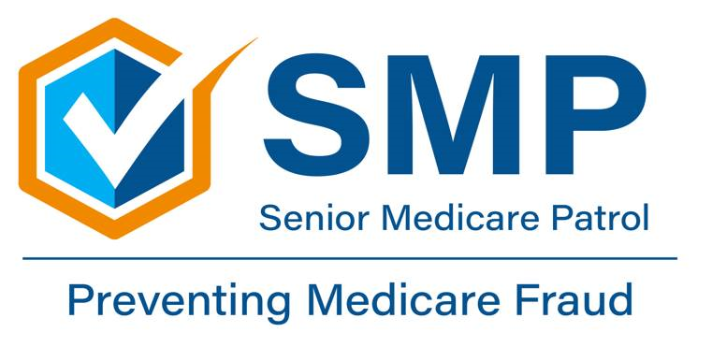
‘Care Share
February 2025
If you or a family member paid out-of-pocket for skilled nursing facility services because you didn’t have a qualifying inpatient hospital stay, you may be able to appeal due to changes as of this month.
A federal district court issued a judgment in the class action lawsuit, Alexander v. Azar (613 F. Supp. 3d 559 (D. Conn. 2020), aff’d sub nom., Barrows v. Becerra, 24 F.4th 116 (2d Cir. 2022), requiring the Centers for Medicare & Medicaid Services (CMS) to establish appeals processes for people enrolled in Original Medicare who are initially admitted to a hospital as an inpatient and subsequently reclassified by the hospital as an outpatient receiving observation services during their hospital stay and who meet other eligibility criteria.
Beginning February 14, 2025, certain beneficiaries in Original Medicare who disagree with a hospital's decision to reclassify their status from inpatient to outpatient receiving observation services (resulting in a denial of coverage for the hospital stay under Part A) will be able to file for an expedited appeal prior to release from the hospital.
Also, beginning January 1, 2025, certain beneficiaries in Original Medicare will be able to file an appeal for denials of Part A coverage of hospital services (and certain skilled nursing facility services) for hospital stays that began on or after January 1, 2009, through the implementation date of the prospective appeals process (February 14, 2025). The deadline for filing these appeals is January 2, 2026.
Inpatient vs. Outpatient Coverage Disputes
One of the most common reasons for retrospective appeals is when Medicare decides a hospital stay was outpatient instead of inpatient. This decision can make a significant difference in what Medicare will pay and how much the patient must pay out of pocket.
Observation Status: Sometimes, patients are kept in the hospital for a few nights but are considered outpatients under "observation status." This can lead to higher costs for the patient and may mean they don’t qualify for skilled nursing care after they leave the hospital. People often appeal these decisions, arguing that their condition was serious enough to require inpatient care.
Skilled Nursing Facility (SNF) Coverage Appeals
To qualify for Medicare to pay for care in a skilled nursing facility, a person usually needs to have spent at least three days as an inpatient in the hospital. If Medicare decides the hospital stay was outpatient, the person might not qualify for SNF coverage. This can lead to expensive bills for nursing home care. Retrospective appeals can help people show that their hospital stay should have been considered inpatient so that their SNF care is covered.
Whether you or your loved one need a prospective (going forward), or retrospective, (looking back), appeal, knowing and understanding your rights can help beneficiaries make sure they aren’t stuck with big medical bills for care they should have been covered for.
You may need to file a retrospective appeal for the following:
- Disagreements about whether a hospital stay should be considered inpatient or outpatient.
- Denials for skilled nursing facility (SNF) coverage
- Claims denied because of paperwork mistakes or missing information.
How to File a Retrospective Appeal
Filing a retrospective appeal can seem complicated, but there are clear steps beneficiaries can follow. These include:
- Review the Denial Notice: Medicare will send a letter explaining why the claim was denied. This letter is an important starting point for an appeal.
- Gather Supporting Documents: Collect medical records, doctor’s notes, and any other information that shows why the service should have been covered.
- Submit the Appeal: File the appeal with the appropriate Medicare contractor. Include all supporting documents and a clear explanation of why you believe the claim should be paid.
- Follow Up: Stay in touch with Medicare and be prepared to provide more information if needed.
Retrospective appeals are an important way for Medicare beneficiaries to make sure they get the coverage they deserve. Whether it’s a dispute about inpatient versus outpatient status or a denial for skilled nursing care, appealing Medicare’s decisions can help reduce the financial burden on beneficiaries. Understanding the appeal process and knowing how to gather the right information can make a big difference in the outcome of a case.
Sourced from CMS.gov https://www.cms.gov/medicare/appeals-grievances/original-medicare-appeals/hospital-appeals-change-inpatient-status-alexander-v-azar#:~:text=Beginning%20January%201%2C%202025%2C%20certain,services%20made%20by%20the%20hospital.

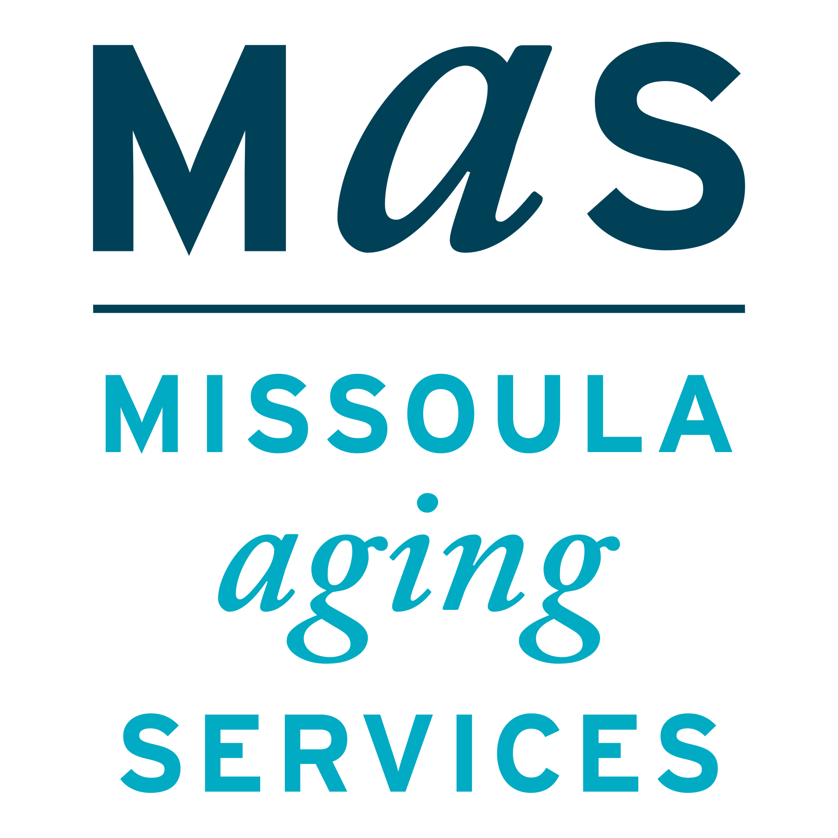
Important Changes Regarding Coverage Appeals
Montana SMP is a program coordinated by Missoula Aging Services and partnered with local Area Agencies on Aging. This project was supported by grant #90MPPG0052 from the U.S. Administration for Community Living, Department of Health and Human Services, Washington D.C., 20201. Points of view or opinions do not necessarily represent official ACL policy.
The Senior Medicare Patrol (SMP) is ready to provide you with the information you need to PROTECT yourself from Medicare fraud, errors, and abuse; DETECT potential fraud, errors, and abuse; and REPORT your concerns. SMPs help educate and empower Medicare beneficiaries in the fight against health care fraud. Your SMP can help you with your questions, concerns, or complaints about potential fraud and abuse issues. It also provides information and educational presentations. To reach Montana Senior Medicare Patrol, call 1-800-551-3191 or visit www.smpresource.org.

