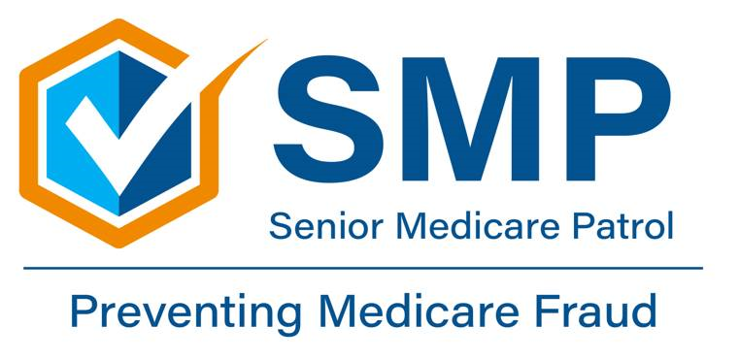
‘Care Share
November 2025
Hello, Medicare Beneficiaries!
In this month’s edition of the Montana ‘Care Share newsletter, we want to talk with you about Durable Medical Equipment fraud, since Montana SMP has lately been receiving an increased number of complaints, and we want you to be aware and protected!

What is Durable Medical Equipment?
Let’s jump in! Durable Medical Equipment (DME) and/or orthotics are considered medical equipment prescribed by your doctor that can withstand repeated use, serve a medical purpose, and can be used in the home. Common examples include, but are not limited to, blood sugar monitors and test strips, canes, walkers, and braces.

What is DME Fraud?
DME and orthotics companies offer a valuable service by providing these types of equipment. However, many fraudulent companies across the country are charging Medicare beneficiaries for this equipment without showing the medical necessity and sometimes without even sending the equipment to the beneficiaries.

DME scam examples in Montana
Montana SMP has lately been receiving an increased number of complaints from beneficiaries regarding DME scams. Here are a few examples from the last month:


- A supplier claiming to be from Medicare called a MT beneficiary and offered to send them “free” equipment. The supplier asked for the beneficiary’s Medicare number, Social Security Number, and names of their doctors/providers. The beneficiary was able to prevent medical identity fraud by refusing to offer or confirm any information. The beneficiary also was able to prevent DME fraud by refusing to accept the offer of equipment. The beneficiary then was able to report the potential frauds by contacting their local SMP.

- Another example of a DME scam occurred when a MT beneficiary noticed 5 claims on their Medicare Summary Notice (MSN)/ Explanation of Benefits (EOB) for DME that they had never ordered or received. The supplier had billed Medicare thousands of dollars for this equipment. The beneficiary was able to prevent DME fraud by carefully reading their MSN/EOB. The beneficiary was then able to detect fraud by noticing that the billed items did not match what they had ordered/received. The beneficiary lastly was able to report the fraud by contacting their local SMP.
- Our last example of a DME scam occurred when a MT beneficiary received 5 sets of braces in the mail that they had not ordered/requested. The beneficiary realized that something didn’t add up, so they were able to report the DME fraud by contacting their local SMP.
What else can DME fraud/scams look like?
Each scenario can be a bit different. Other DME fraud/scams can occur, such as:

- Suppliers who want you to use their doctors (not yours), who then prescribe unnecessary medical equipment.
- Suppliers or doctors who provide medical equipment or supplies you never requested.
- Suppliers or doctors who charge for items you never received.
- Suppliers who bill for people who have passed away.
- Suppliers who request your Medicare number at a presentation, during a sales pitch, or in an unsolicited phone call.
- Beneficiaries who willingly allow their Medicare number to be used in exchange for money, gifts, or unnecessary equipment and supplies.
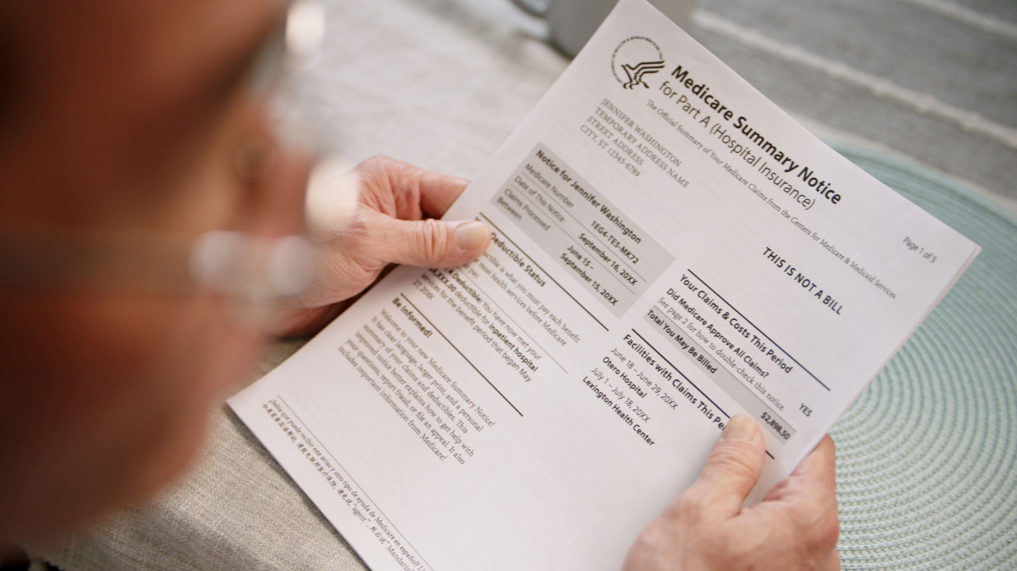

What can you do to stop DME fraud?
- Be sure your doctor has assessed your condition and orders any equipment or supplies.
- Never sign a blank form from your health care provider or equipment supplier.
- Always read your Medicare Summary Notice (MSN) or Explanation of Benefits (EOB). Look for charges for equipment you do not need, never requested, or did not receive.
- If you rent and return medical equipment, always get a dated receipt.
- Protect your Medicare, Medicaid, and Social Security cards like credit cards.
- Do not accept products or services from strangers who call or knock on your door.
- Do not give out your Medicare number at a presentation or during a sales pitch.
- Do not accept money, gifts, or unnecessary equipment and supplies from a supplier in exchange for your Medicare number.

How can your local SMP help?
Your local SMP can help educate and empower Medicare beneficiaries in the fight against health care fraud. Your SMP can help you with your questions, concerns, or complaints about potential fraud and abuse issues. It also can provide information and educational presentations. Always feel free to reach out!

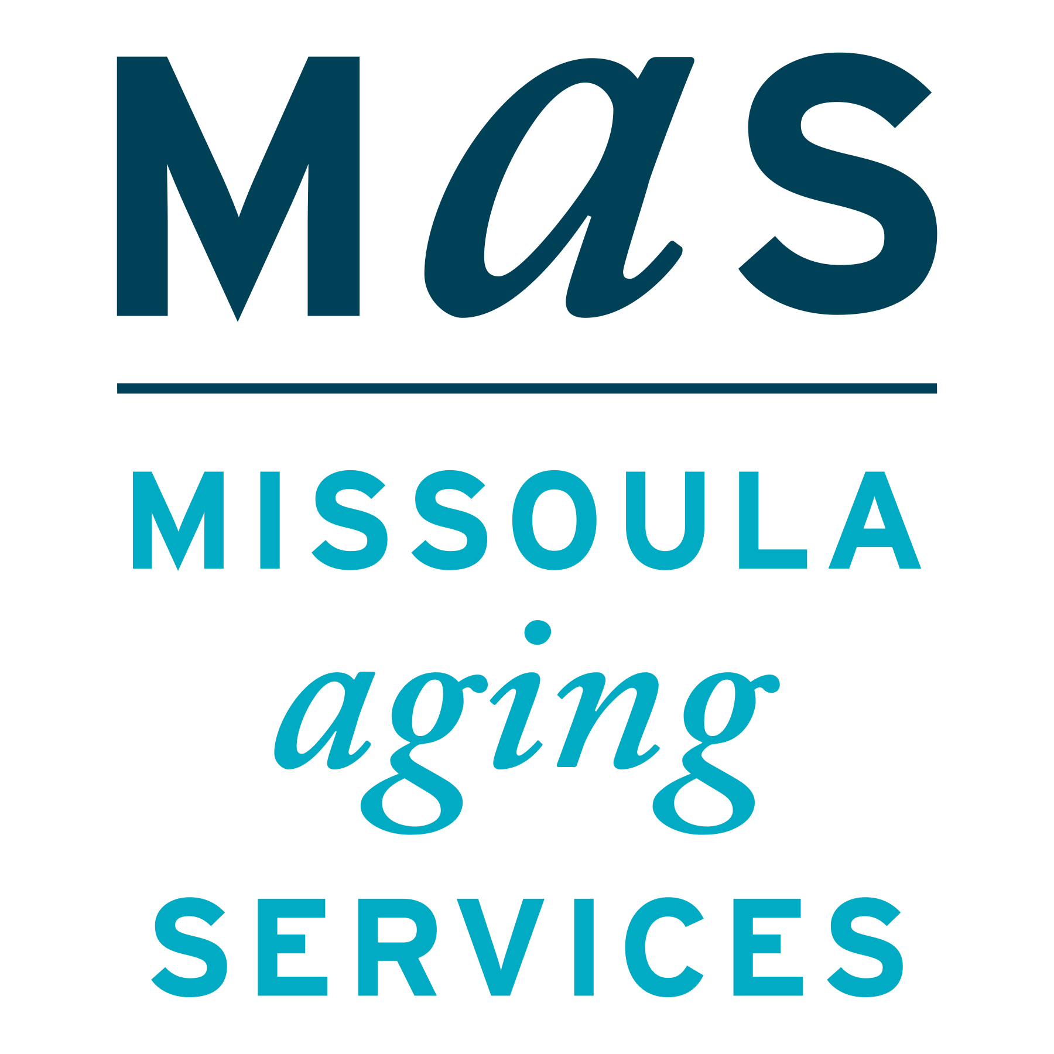
Durable Medical Equipment Fraud Schemes
Montana SMP is a program coordinated by Missoula Aging Services and partnered with local Area Agencies on Aging. This project was supported by grant #90MPPG0095 from the U.S. Administration for Community Living, Department of Health and Human Services, Washington D.C., 20201. Points of view or opinions do not necessarily represent official ACL policy.
The Senior Medicare Patrol (SMP) is ready to provide you with the information you need to PROTECT yourself from Medicare fraud, errors, and abuse; DETECT potential fraud, errors, and abuse; and REPORT your concerns. SMPs help educate and empower Medicare beneficiaries in the fight against health care fraud. Your SMP can help you with your questions, concerns, or complaints about potential fraud and abuse issues. It also provides information and educational presentations. To reach Montana Senior Medicare Patrol, call 1-800-551-3191 or visit www.smpresource.org.

