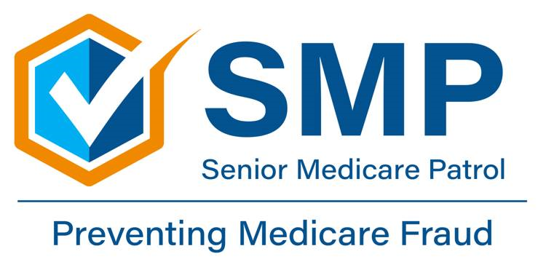
‘Care Share
December 2025

Hello, Medicare Beneficiaries!
In this month’s edition of the Montana ‘Care Share newsletter, we want to talk with you about Medical Identity Theft in Montana. We want you to be aware and protected!

What is Medical Identity Theft?
Let’s jump in! Medical identity theft is when someone fraudulently gets and uses your personal information, like your:
- Name
- Medicare number
- Social Security number
- Driver’s license number
- Address
To then use this information to:
- Get medical treatment
- Buy medical equipment
- Get prescriptions
- Submit claims to your health insurance for items you don’t need, request, or may have never received.

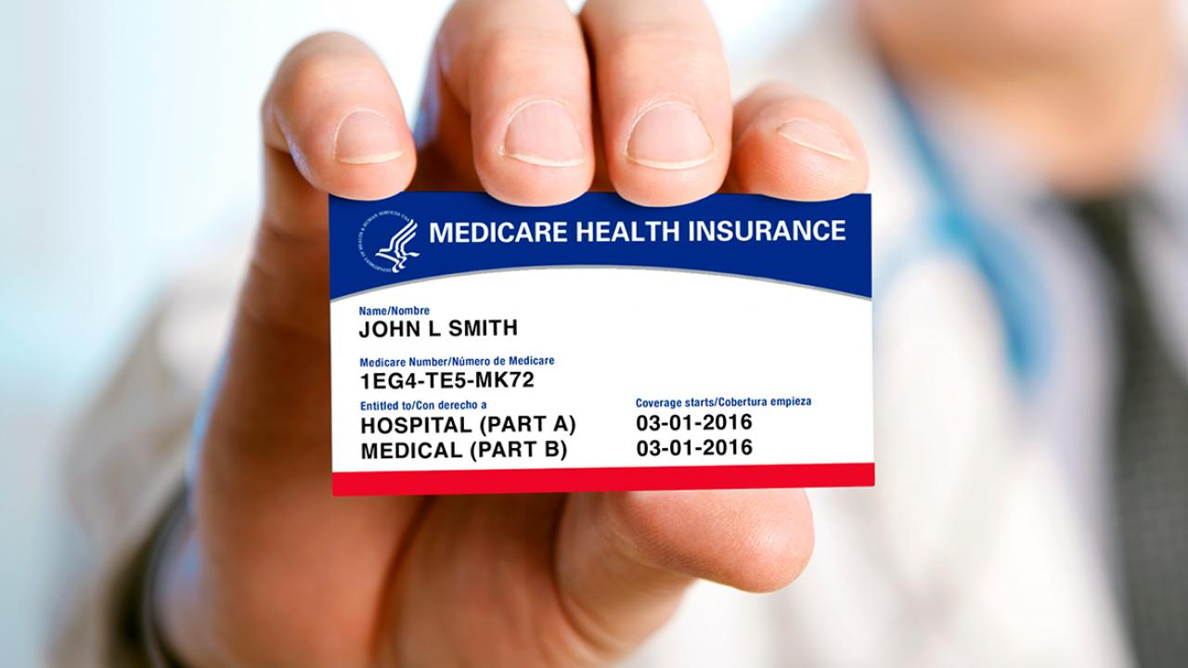

Medical Identity Theft examples in Montana
Montana SMP often receives a number of complaints from beneficiaries regarding medical identity theft scams. Here is an example from the last month:

- A local beneficiary received calls from multiple phone numbers. Each caller claimed to be from Medicare and stated they needed to “check” her Medicare number. The beneficiary did not recognize the phone numbers and realized that the callers were refusing to identify themselves. As a result, she was rightly suspicious! The beneficiary was able to prevent medical identity theft by refusing to offer or confirm any information. The beneficiary then was able to report the potential scams by contacting her local SMP.

Another common story of beneficiary complaints in Montana is that scammers state that Medicare is issuing new cards. The scammers argue that they need to confirm their Medicare number in order to send a new card. This is not true and should always be a red flag for a potential scam.

Some scammers also call and offer “free” services in exchange for a beneficiary’s Medicare number. These could include things like “free” COVID-19 tests, back or knee braces you didn’t ask for, genetic testing, cancer screening kits, “new” Medicare cards, and telehealth. Be wary of these claims as well, and remember: If someone is exchanging a service for your information, it’s not really free!

What else can Medical Identity Theft look like?

- Charges and providers on your Medicare statements that you don’t recognize
- Shipments of back or knee braces, testing kits, or other medical supplies that you didn’t ask for
- Contact from a debt collection company for a provider bill that you don’t owe
- Medicare and/or your Medicare Advantage (MA) plan denies or limits your coverage or benefits because of a medical condition you do not have or says you already received a product or service when you did not

What can you do to stop Medical Identity Theft?

- Be careful about who you give your personal information to!
- Never give out your Medicare number to anyone who contacts you through unexpected or unknown calls, texts, or emails.
  - Remember that Medicare and Social Security will never reach out to you to ask for your personal information.
- Keep documents that contain your medical information somewhere safe.
- If you believe someone has stolen your medical information, contact your local Senior Medicare Patrol (SMP).

How can your local SMP help?
Your local SMP can help educate and empower Medicare beneficiaries in the fight against health care fraud. Your SMP can help you with your questions, concerns, or complaints about potential fraud and abuse issues. It also can provide information and educational presentations. Always feel free to reach out!
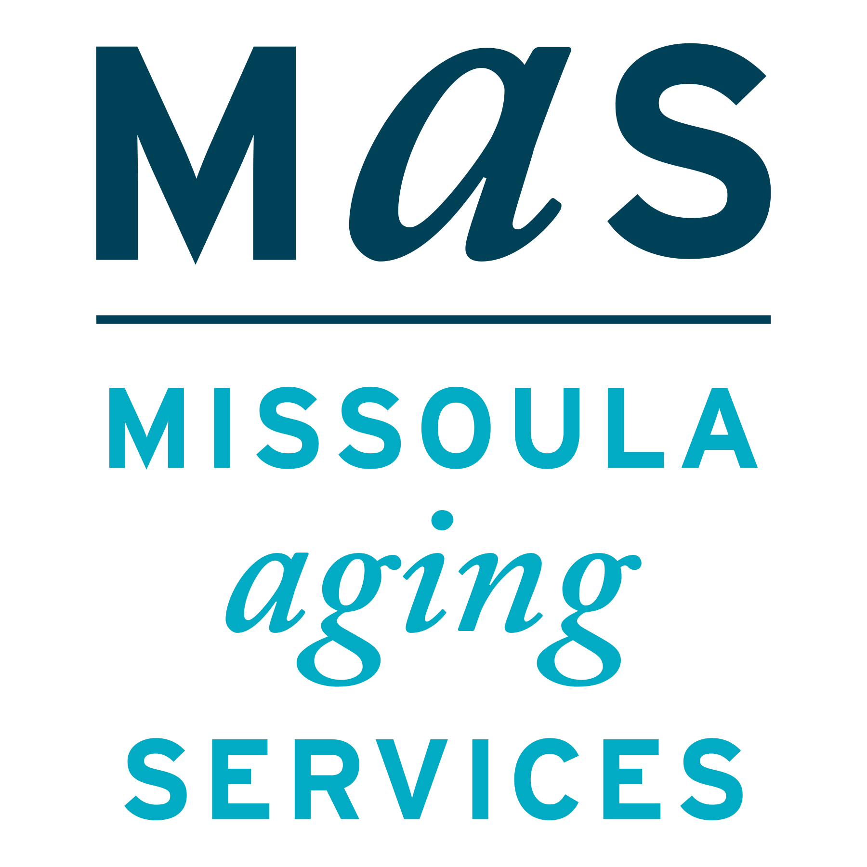
Medical Identity Theft
Montana SMP is a program coordinated by Missoula Aging Services and partnered with local Area Agencies on Aging. This project was supported by grant #90MPPG0095 from the U.S. Administration for Community Living, Department of Health and Human Services, Washington D.C., 20201. Points of view or opinions do not necessarily represent official ACL policy.
The Senior Medicare Patrol (SMP) is ready to provide you with the information you need to PROTECT yourself from Medicare fraud, errors, and abuse; DETECT potential fraud, errors, and abuse; and REPORT your concerns. SMPs help educate and empower Medicare beneficiaries in the fight against health care fraud. Your SMP can help you with your questions, concerns, or complaints about potential fraud and abuse issues. It also provides information and educational presentations. To reach Montana Senior Medicare Patrol, call 1-800-551-3191 or visit www.smpresource.org.

